**PRIMARY THREE**

**LITERACY II LESSON NOTES**

**FOR**

**TERM 111**(2015)

C**OMPILED BY;**

1. ALEX MUTOTO
2. ROBERTSON WANZU
3. BETTY AKELLO
4. ISAAC BUYUNGO
5. FLORENCE NAMAGEMBE

**WEEK:2** Lesson1&2

**Spellings**

1. receive
2. social
3. transport
4. service
5. ethnic

**GENDER AND CULTURE IN OUR SUB-COUNTY**

**Culture**

1. **What is culture**?

Culture is the way people live and behave in a given society.

2. **Aspects or components of culture**

Culture includes the following;

* customs
* food
* taboos
* language
* religion/beliefs etc

**Customs**

3. **What are customs**?

Customs are traditional or religious practices in a society.

Customs are acceptable behaviour in a society.

4. **Examples of customs/ cultural practices**

* marriage
* naming children
* greeting
* dressing
* dancing
* burial
* tattooing
* twin celebration
* male circumcision e.g. among the Bagisu
* genital mutilation e.g. among the Sabiny

**Exercise**

1. Define the term culture.
2. Identify any three components of culture.
3. What are customs?
4. Which custom is common among all Bagisu?
5. Mention any other two common customs in our society.

**WEEK: 2** Lesson 3 &4

**Spellings**

1. culture
2. society
3. custom
4. circumcision
5. traditional

**MARRIAGE**

1. **What is marriage**?

Marriage is when a man and a woman become husband and wife.

-Marriage is an agreement/union between a man and a woman as husband and wife.

**2. Types of marriage**

1. Religious marriage
2. Customary /Traditional marriage
3. Civil marriage

**3. Religious marriage**

This takes place in the church, mosque or temple.

-It is done by a religious leader e.g Reverend, Imam, Pastor, Priest etc.

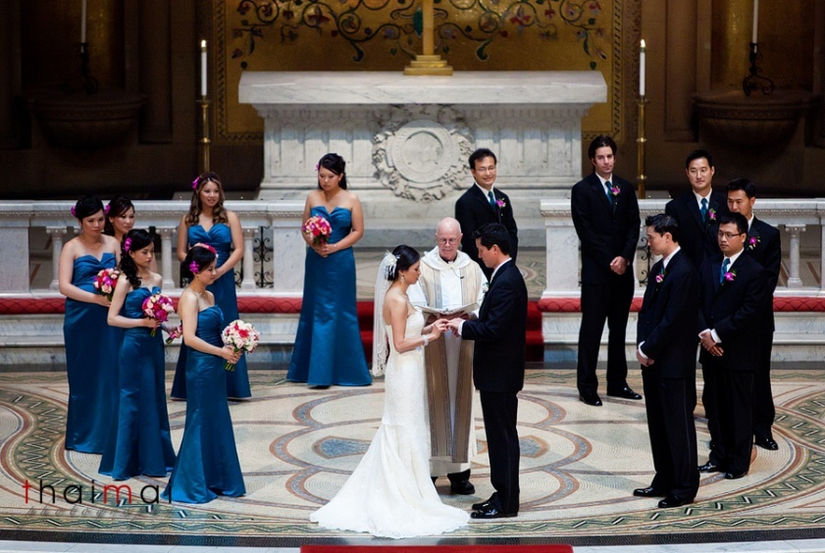

**A photograph showing a religious marriage**

**Exercise**

1. What is marriage?
2. Name three types of marriage.
3. Who officiates a religious marriage?
4. Identify any one place where a religious marriage can take place.

**WEEK: 2** Lesson 5&6

**Spellings**

1. marriage
2. religious
3. union
4. agreement
5. reverend

**1. Customary /Traditional marriage**

Here the groom takes bride price/ bride wealth to the girl’s parents before he is given the girl for marriage.

- It can also be called **cultural marriage**.

**2. What is bride price**?

Bride price is the money or items that the groom gives to the bride’s family before he is given the bride.

-It can also be called **bride wealth/ dowry.**

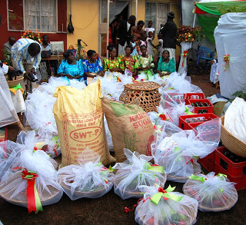

**A photograph showing some of the things taken by the groom during a customary marriage**

**3. Examples of bride price items given today**

* cows
* goats
* cocks
* clothes
* sodas
* beers
* cars
* fruits
* chairs etc

**Exercise**

1. King is to queen as groom is to\_\_\_\_\_\_\_\_\_\_\_.
2. What do we call the items paid to the bride’s family by the groom?
3. Draw, name and colour any four examples of such items.

**WEEK: 2** Lesson 7

**Spellings**

1. bride price
2. dowry
3. groom
4. cultural
5. customary

1. **Civil marriage**

This is the type of marriage that is done before a government officialcalled the **Chief Administrative Officer.** **(CAO)**

-A marriage certificate is given in the presence of witnesses.

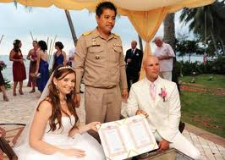

**2. Qualities of a good marriage partner**

* Should be educated
* Should be respectful.
* Should be God-fearing.
* Should not be too old or too young.
* Should be loving.
* Should be healthy

**Exercise**

1. Write CAO in full.
2. State three qualities of a good marriage partner.

**WEEK: 3** Lesson 1&2

**Spellings**

1. civil
2. chief
3. administrative
4. certificate
5. witness

**1. Problems in marriage**

* Divorce; Separation of married partners/couples.
* Quarrels
* Poverty
* Child abuse
* Alcoholism
* Debt burden
* Adultery; Sex outside marriage
* Sexually Transmitted Diseases (STDs) like AIDS

NB: The problems of marriage are the causes of divorce.

**2. Effects of divorce to children**

* Children lack basic needs.
* Abuse of children by step parents.
* Lack of parental love.
* Children go to the streets.

**Exercise**

1. Give any three problems facing marriages/ families today.
2. State two ways how any of the above problems be controlled.
3. How does divorce affect children?

**WEEK: 3** Lessons 3& 4

**Spellings**

1. divorce
2. couples
3. poverty
4. adultery
5. alcoholism

**GREETING**

1. In most tribes, boys/men greet while standing upright while girls/women kneel down.

-This is done as a sign of respect.

**2. Why we greet**

* To show respect
* To build relationship
* To create unity

**DRESSING**

3. Tribes have different traditional and cultural wears.

**4. A table showing tribes and their traditional wear**

|  |  |
| --- | --- |
| **Tribe(S)** | **Traditional wear** |
| Baganda and Basoga | Men-Kanzu  Women-Gomesi/Busuuti |
| Banyankole,Batooro,Banyoro | Men-Kanzu  Women-Mushanana/sash |
| Karimojong | Beads |

**NB;** Bark cloth is the cultural dress for the Baganda people while the kanzu is their traditional wear for men and gomesi for ladies.

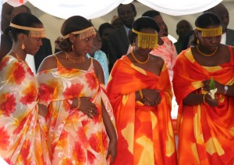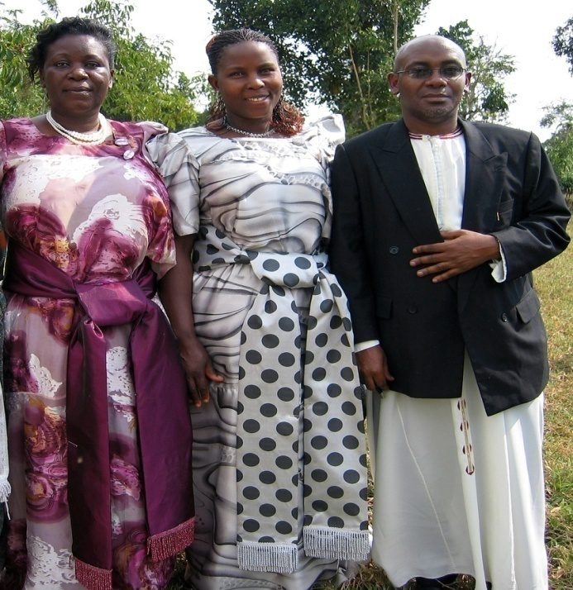

Ankole ladies in Mushanana Baganda ladies in Gomesi & a man in

Kanzu

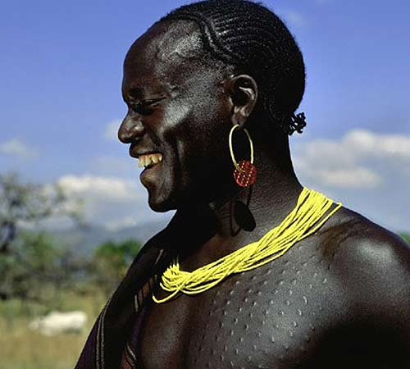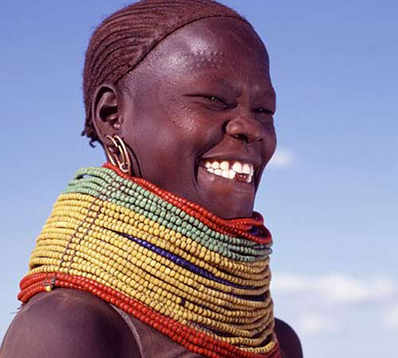

**A Karimojong man with beads A Karimojong woman with beads**

1. **Examples of modern clothes**

* suits
* skirts
* shirts and blouses
* kundi- shows
* leggings
* jackets etc

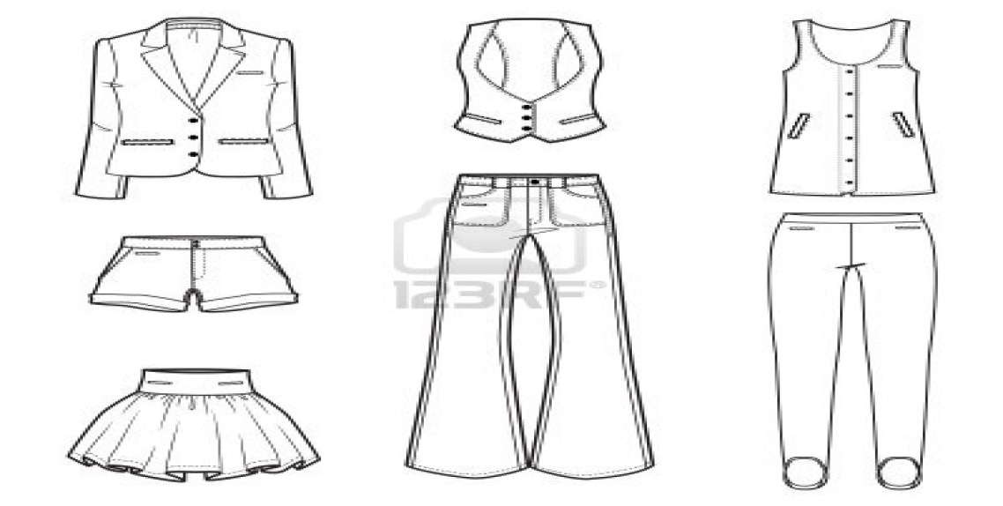

**5. Why people wear clothes.**

* For easy identification.
* To be smart.
* For privacy.
* To promote culture.

**Exercise**

1. Why do we greet people?
2. Identify the traditional wear for these tribes.
3. Baganda
4. Karimojongs
5. Banyankole

3. Why do people wear clothes?

**WEEK:3** Lesson 5 &6

**Spellings**

1. greet
2. identification
3. respect
4. kneel
5. relationship

**CHILD NAMING**

1. Children are named differently according to tribes, religions and clans.

2. Long ago and today, newly born babies are given names by their parents, paternal grand fathers or clan heads.

3. Names given are of the fallen dear ones, physical features, seasons of the year or at the time of the day when the child was born.

4. Different names carry different meanings e.g.

|  |  |  |
| --- | --- | --- |
| **Name** | **Meaning** | **Tribe** |
| Kasozi | Hill | Baganda  ‘’  ‘’  ‘’  ‘’ |
| Lutalo | War |
| Kiwanuka | Thunder |
| Walumbe | Death |
| Musisi | Earthquake |
| Nabwire | Night (for girls) | Samia  “ |
| Wabwire | Night (for boys) |
| Wanzala | Famine | Samia /Bagisu |

**5. Why children are given names.**

* For identification.
* To promote culture.

**Exercise**

1. What do you call the father of your father?
2. Give one reason why children are given names.
3. What do these Baganda names mean?
4. Walumbe
5. Musisi
6. Kasozi

**WEEK:3** Lesson 7&1

**Spellings**

1. religion
2. paternal
3. thunder
4. famine
5. earthquake

**Naming of twins**

In different tribes, twins and their parents are given special names e.g.

|  |  |  |
| --- | --- | --- |
| **Names of twins** | **Sex** | **Tribe** |
| Babirye | Female (old) | Baganda |
| Nakato | “ (young) |
| Wasswa | Male (o) |
| Kato | “ (Y) |
| Babirye | Female (o) | Basoga |
| kawudha | “ (y) |
| Waiswa | Male (o) |
| Tenywa | “ (y) |
| Isingoma | Male (o) | Banyankole, Batooro, Banyoro, Bakiga |
| Kato | “ (y) |
| Nyangoma | Female (0) |
| Nyakato | “ (o) |
| **Names of Parents** |  |  |
| Isabirye | Father of twins | Basoga |
| Nabirye | Mother of twins |
| Isabalongo | Father of twins | Banyankole, Batooro, Banyoro, Bakiga |
| Nyinabalongo | Mother of twins |
| Salongo | Father of twins | Baganda |
| Nalongo | Mother of twins |

**Exercise**

1. What do we call two children born at the same time by the same mother?
2. Write two twin names for boys in Baganda tribe.
3. Who is the twin father and mother among the Banyankole?
4. Father
5. Mother

**WEEK:4** Lesson 2 &3

**Spellings**

1. twins
2. special
3. male
4. female
5. young

**FOOD**

1. **What is food?**

Food is anything we eat or drink and is useful in the body.

2. **What is a staple food?**

This is a type of food eaten by most people in an area or region.

3. Tribes have different food dishes or staple foods.

**4. A table showing traditional dishes/staple foods for different tribes**

|  |  |
| --- | --- |
| **Tribe** | **Food dish** |
| Baganda | Matooke |
| Banyankole | Millet(kalo) mixed with cassava flour, matooke |
| Samia | Millet mixed with cassava flour |
| Basoga | Sweet potatoes and posho |
| Iteso | Millet mixed with cassava flour |
| Acholi | Millet /sorghum mixed with cassava flour |

**Exercise**

1. Define the term staple food.
2. What is the staple food for the following tribes?
3. Basoga
4. Banyankole
5. Baganda
6. Identify one tribe whose traditional food is millet?

**WEEK:4** Lesson 4 &5

**Spellings**

1. staple food
2. traditional
3. dishes
4. flour
5. sorghum

**FOOD TABOOS**

**1. What is a food taboo?**

This is a forbidden food in a given society.

A food taboo is a type of food that a person of a given tribe, religion or clan is not allowed to eat.

e.g.

* Moslems do not eat pork.
* Clans do not eat their totems.
* Hindus do not eat meat.
* The Seventh day Adventists do not eat pork.

**2. Importance of customs in a society**

* They attract tourists.
* They promote culture.
* They promote morals in society.
* They are for study purposes.
* Customs promote unity/co-operation.

**Exercise**

1. What does the word food taboo mean?
2. Identify any two common food taboos.
3. What is your totem?
4. State two ways how customs can be useful to us.

**WEEK:4** Lesson 6

**Spellings**

1. taboo
2. society
3. forbidden
4. totem
5. morals

**Clans**

1. What is a clan?

A clan is a group of people under the same forefather or ancestor.

**2. Symbols of a clan**

1. Names
2. Drum sound
3. Totem
4. Forefather/ancestor

**3. Duties of a clan head**

i) Settles disputes/ conflicts among clan leaders.

ii) Registers clan members and the newly born babies.

iii) Keeps clan records.

iv) Organizes clan meetings.

**Exercise**

1. What is a clan?
2. Name any two symbols of a clan.
3. Give two roles of a clan head.

**WEEK:4** Lesson 7&1

**Spellings**

1. clan head
2. fore-father
3. symbols
4. ancestor
5. disputes

**Forms of clans in Buganda**

1. Clans are grouped into;

1. Animal form
2. Bird form
3. Insect form
4. Plant form
5. Others

2. **Examples in each form**

1. **Animal form**

* Mpologoma(lion)
* Ngo(leopard)
* Ngabi(antelope)
* Nkima(monkey)
* Nte(cow)
* Mbwa(dog)
* Ndiga (sheep)
* Njovu(elephant)
* Nvuma(hippo) etc

**b) Bird form**

* Nyange(egret)
* Nakinsige
* Namungoona (raven/crow)
* Ngaali (crested crane) etc

**c) Plantform**

* Kobe
* Butiko(mushroom)

**d) Insect form**

* Nsenene (grasshopper)
* Kinyomo

e) **Others**

* Nkebuka
* Mutima(heart)
* Amazzi g’ekisasi
* Lukato etc

**Exercise**

1. Name any two animal forms of tribes in Buganda.
2. Identify any other two forms of clans in Buganda.
3. Which is the ruling clan in Buganda?
4. What title is given to the king of Buganda?
5. Who is current king of Buganda.
6. Write the name of your clan.

**WEEK:5** Lesson 2&3

**Spellings**

1. Buganda
2. Bunyoro
3. crested crane
4. crow
5. egret

**Ways of promoting/preserving culture**

* Through music and dance.
* By sharing roles and responsibilities.
* Writing in books.
* Attending clan meetings.
* Through cultural education (socialization)
* Through initiation.
* Attending funerals and other cultural festivals.
* Respecting cultural norms.
* Visiting elders.
* Planting medicinal plants like molinga and mulondo tree.
* Installation and enthroning cultural leaders like kings.
* Through succession.

**Exercise**

1. State any four ways of preserving our culture.
2. Why do people attend burial ceremonies?
3. Identify any one role of cultural leaders.
4. Why should children be taught their cultures?

**WEEK:5** Lesson 4&5

**Spellings**

1. preserve
2. funeral
3. festival
4. norms
5. medicinal

**1. Importance of cultural practices**

* They teach good morals.
* They help us to preserve culture.
* They help people to know more about their tribes.
* For cultural identity.
* They attract tourists.

**2. Dangers of cultural practices**

* Some practices spread of diseases like HIV/AIDS
* Some names given have bad effects/impacts on the children e.g. ‘Nddikulwange’ meaning ‘being lonely’.
* Some obscene words and songs are used during naming of twins.
* Some cause public shame e.g. open circumcision.
* Some people are allergic to some cultural foods.
* Forbidding people from eating some foods leads to malnutrition.
* Some cultural practices are against human rights e.g. FGM

**NB**: FGM in full is Female Genital Mutilation

-It can also be called female circumcision.

-It is common among the **Sabiny** in Kapchorwa district.

**Exercise**

1. Identify any one danger of food taboos to people.
2. Which tribes in Uganda carry out these types of circumcision?

a. Male circumcision

b. Female circumcision

1. Why is male circumcision useful?
2. How can culture be dangerous to people?

**WEEK:5** Lesson 6&7

**Spellings**

1. identity
2. allergic
3. practice
4. malnutrition
5. obscene

**GENDER**

1. **What is gender?**

Gender are the roles played by men and women in a society.

-Sex is the state of being male or female.

**2. Types of gender**

There are two types of gender namely;

1. Masculine gender; Roles played by men/males.
2. Feminine gender; Roles played by women/females.

**3. Traditional gender roles**

-In the traditional society males and females played different roles.

a) **Men /boys**

* Hunting
* Fishing
* Looking after cattle.
* Protecting the family.
* Building the house.

b) **Females/girls**

* Producing children.
* Cleaning the home.
* Taking care of the children and the husband.
* Cooking food for the family members.

**Exercise**

1. What is the difference between gender and sex?
2. Identify the two types of gender.
3. Which roles were played by these people in the traditional society?
4. men
5. women

**WEEK**:**6** Lesson 1&2

**Spellings**

1. gender
2. masculine
3. feminine
4. traditional
5. male

**Gender roles in our modern society**

1. In our modern society both men/boys and women/girls can share work/roles.

**2. Activities done by both girls and boys**

* Fetching water
* Going for fishing
* Hunting and fishing
* Sweeping the compound
* Going for shopping
* Washing clothes
* Cooking food
* Driving
* Fetching firewood
* Mopping the house
* Milking the cows
* Taking care of the baby
* Fetching firewood

1. **Misunderstanding of gender in societies**

In the traditional society and in some few societies, people misunderstood gender in the following ways;

* Women were used as sex machines by men.
* Boys were considered to be brighter than girls.
* Boys were taken to school while girls are not.
* Men were considered to be stronger than women.
* Women were not allowed to speak in public.

**Exercise**

1. Identify any two activities that both girls and boys can do at home.
2. How were girls treated differently from boys in society?

**WEEK: 6** Lesson 3&4

**Spellings**

1. roles
2. modern
3. cattle
4. building
5. husband

**Gender equity**

1. What is gender equity?

This is the treating of both boys (males) and girls (females) fairly/equally.

2. Work between boys and girls must be divided equally.

3. Boys and girls must be given equal rights

**4. Ways of promoting gender equity**

* Fair distribution of work.
* Providing needs to both boys and girls.
* Giving fair punishments to both boys and girls
* Giving equal opportunities to both boys and girls
* Allowing both boys and girls to express their feelings freely.
* By educating both the girl and the boy child.

**5. What shows that girls and boys are equal?**

* Both boys and girls can excel in studies.
* Both boys and girls are equally bright.
* Girls can do jobs that boys do.
* Both are human beings.
* Both can do all games and sports.
* Both have emotions.

**Exercise**

1. What is gender equity?
2. State two ways of promoting gender equity in a home.
3. Why girls and boys should be treated equally?

**WEEK:6**Lesson 4

**Tropical test**

1. What is culture?
2. Name any two dangerous cultural practices.
3. Give any two importance of culture.
4. What is gender equity?
5. How is can we promote gender equity at school
6. Identify any one food taboo
7. State any two ways we can preserve our African culture.
8. What do we call the acceptable behavior in a society?
9. Mention any two activities that can be done by both boys and girls.
10. What is marriage?
11. Why do people marry?
12. Give any two effects of divorce to the children.
13. How are customs important to us?

**WEEK: 6** Lesson 5

**Spellings**

1. equity
2. equally
3. promote
4. opportunity
5. misunderstanding

**THEME: BASIC TECHNOLOGY IN OUR SUB-COUNTY/DIVISION**

1. What is technology?

Technology is the use of machines to do work.

It is the use of scientific knowledge to do work.

**2. Types of technology**

1. Traditional technology
2. Modern or advanced technology

**a. Traditional technology**

This is the use of local methods and equipment like hoes, hands to creatively make things.

**b. Modern technology**

This is the use of advanced scientific equipment like computers, phones, cars and tractors to simplify work.

**Exercise**

1. What term is used to mean the use of machines to simplify work?
2. Draw name and colour two things used in this modern technology.
3. Which type of technology was used by people of long ago?

**WEEK: 6** Lesson 7&1

**Spellings**

1. technology
2. scientific
3. knowledge
4. machines
5. equipment

**Natural and artificial materials in our sub-county**

1. Things in our environment are made from natural and artificial materials

**2. Natural materials**

These are materials got from nature.

**3. Examples of natural materials;**

* Banana fibres
* Palm leaves
* Clay
* Sisal
* Minerals
* Papyrus
* Wood
* Grass
* Hides and skills

**4. Sources of natural materials**

|  |  |
| --- | --- |
| **Materials** | **Source** |
| banana fibres | banana plantations |
| sisal and fruits | plantations |
| clay, papyrus and palm leaves | swamps |
| minerals | mines |
| hides and skins | animals |

**Exercise**

1. Identify any three natural materials in our environment.
2. Where are these materials got?
3. Sisal
4. Minerals
5. Name any two raw materials got from swamps.

**WEEK: 7**Lesson 1&2

**Spellings**

1. natural
2. materials
3. environment
4. plantation
5. papyrus

**1. Processing and making things from natural materials**

The table below shows things made from natural materials.

|  |  |
| --- | --- |
| **Material** | **Things made/products** |
| clay | pots, cups, plates, stoves etc |
| palm leaves and banana fibres | mats, dolls, bags, hats |
| Wood | stools, tables, chairs, sculpture |
| sisal | ropes, carpets, door mats, bags |
| Grass | brooms |
| iron | arrows, spears , hooks ,hoes |
| Beads | necklaces, rosaries |
| Fruits | Juice and salads |

|  |  |  |
| --- | --- | --- |
| EthiopianStool07 | Carved-Giraffe-12-inches | East African Crafts - hand made baskets |
| stool | basket |
| Placemats hand crafted in East Africa - | hat |
| doormat | sculpture of a giraffe | hat |

2. Who is a blacksmith?

Is a person who makes things out of iron.

3. **Things made by a blacksmith;**

* spears
* hoes
* arrows
* hooks
* stoves
* pans

**Exercise**

1. Which raw materials are used for making these items?
2. ropes
3. necklaces
4. mats
5. arrows
6. Who is a potter?
7. Draw, name and colour any three items made by a potter.

**WEEK:7** Lesson 3&4

**Spellings**

1. iron
2. blacksmith
3. banana fibres
4. palm leaves
5. necklace

1**. Artificial materials**

These are re-cycled materials that can be used to make other things.

2**. Examples of artificial materials**

* wires
* plastics
* straws
* scrap metals
* paper
* polythene bags
* synthetic rubber
* bottle tops

**3. Processing and making things from artificial materials.**

The table below shows things made from natural materials.

|  |  |
| --- | --- |
| **Material** | **Products** |
| plastics | mugs, plates, doll, toys |
| wires | toys, hooks, traps |
| straws | materials, bags, decorations |
| polythene bags | balls, dolls, bags |
| paper | bags, envelopes, decoration etc |
| scrap metal | nails, garden tools like hoes |
| bottle tops | toys, abacuses and shakers |

4**. Importance of things made from natural and artificial materials**

* Toys and dolls are used as play kits.
* Some are used for decoration.
* People sell them to get money.
* Some are worn as ornaments.
* They are for study purpose.
* They attract tourists.

**Exercise**

1. Which artificial raw materials are used for making these items?

1. balls
2. envelopes
3. mugs

2. State any two uses of crafts to people.

**WEEK: 7** Lesson5&6

**Spellings**

1. artificial
2. plastic
3. polythene
4. scrap
5. decoration

**CRAFTS**

1. What are crafts?

These are things made from local materials like palm leaves, banana fibres, clay etc.

2**. Examples of crafts**

* dolls
* mats
* ropes
* vases
* stoves
* stools
* carpets

|  |  |  |
| --- | --- | --- |
| **african** | hat | East African Crafts - hand made shoes |
| bracelet | hat | sandals |
| **ANd9GcTj_Y0_vRqIaUdYCoyn4MmLSp6yBz6dhEG3U9RsUT_b3dhUWRO3** | **East African Crafts - hand made placemats** | **Hand made jewellery from east africa** |
| **bag** | **mats** | **necklace** |

**3. Importance of technology**

How is technology useful to us?

* It makes work easy.
* It makes life better.
* It increases production of goods.

**Exercise**

1. How has technology helped us?
2. A potter is to clay as a \_\_\_\_\_\_\_\_\_is to iron.
3. Define the term crafts.
4. Draw, name and colour any two crafts.

**WEEK: 7** Lesson 7

**Topical test**

1. Define the term technology?
2. Name any one type of technology.
3. Identify the local materials that can be used for making these items
4. ropes
5. pots
6. necklaces
7. What are crafts?
8. How useful is the crafts industry to us?
9. Who is a black smith?
10. Draw and name any two products made by a blacksmith.
11. Which type of technology does a rural potter use?
12. How useful is technology in our daily life?

**“Merry X-mass”**

**THE END**